COMHAIRLE CHONTAE LONGFOIRT

LONGFORD COUNTY COUNCIL

Corporate Affairs,
Aras an Chontae,
LONGFOIRT.

4u Feabhra 2015.

Chuig: Gach Ball don Chomhairle.

A Chomhairleoir,

Iarrtar ort bheith i láthair ag Cruinniú Míosuil Chomhairle Chontae Longfoirt a tionólfar i Seomra na Comhairle, Aras an Chontae, Longfoirt ar an Chéadaoin,
11u Feabhra 2015 ag 4.00 p.m chun gnó a dhéanamh d’réir an Chláir thíos.

You are requested to attend the Monthly Meeting of Longford County Council to be held in the Council Chamber, Aras an Chontae, Great Water Street, Longford, on Wednesday, 11th February 2015 at 4.00 p.m. to transact business, as set out on the Agenda hereunder.

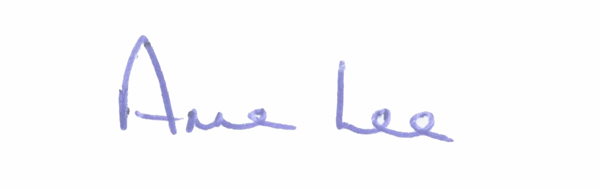
Mise le meas,

_______________
Anne Lee,
Meetings Administrator.

C L A R

Prayer before Meeting.

- Confirmation of Minutes of Monthly Meeting held on 14th January 2015 -
copy enclosed.

2. Matters arising from Minutes.

3. To note adopted Minutes of Corporate Policy Group Meeting held on
10th December 2014 - copy enclosed.

4. To note Chief Executive Orders. (Summary herewith).

5. To note Monthly Management Report - report enclosed.

6. Finance & Information Systems, Housing & Building.

(a) To note Public Liability Claims received during January 2015 – report enclosed.

- Local Government Act 2001 - Annual Ethics Declaration.

- To note Circular LG 3/2015 received from the Department of the Environment, Community and Local Government – Revised arrangements for allowances for expenses incurred by elected members of local authorities - copy enclosed.

- To consider the following recommendation from the
Housing Services Strategic Policy Committee -

“That a letter be forwarded to the Department of the Environment, Community & Local Government requesting grant aid for tenants who wish to revert to traditional methods of heating.”

- To consider the following recommendation from the Economic Development and Enterprise Strategic Policy Committee –

“That Longford County Council writes to the Department of Finance to express dissatisfaction with the Rates Legislation which is over 200 years old and which is having a major negative impact on the commercial sector and to request that the Legislation be updated as a matter of urgency.”

7. Economic and Community Development, Corporate, Cultural & Recreational Services, Human Resources, Planning & Building Control.

- To note Planning Applications received since January meeting of the Council.

(b) To note adopted Minutes of Economic Development and Enterprise
Strategic Policy Committee meeting held on 1st December 2014 –
copy enclosed.

(c) Consideration of Chief Executive’s Report - Proposed Material Alterations to the Draft Longford County Development Plan 2015 – 2021 - dated the 24th December 2014.

(d) To note Circular letter PL1/2015 dated 30 January 2015 from the Department of Environment, Community and Local Government re Planning Policy Statement 2015.

- To note Circular LG 1/2015 and AL 1/2015 Local Economic and Community Plans - enclosed.

- To note Consultation Paper on the Establishment of an Electoral Commission in Ireland - enclosed.

- Consideration and approval of Draft Corporate Plan 2014 – 2019.
- to follow

- Draft Rates Incentive Scheme.

- Proposed Regeneration Plan for Longford.

- To consider the following recommendations from the Economic Development and Enterprise Strategic Policy Committee –

  - That Longford County Council write to the Department of Jobs, Enterprise and Innovation to express its concern that there are no strategies in place to provide economic support to SMEs with greater than 10+ employees who are not in the export market and to urgently introduce support strategies to cater for this important Business Sector.

  - That Longford County Council write to the Health Service Executive and to the Minister for Health, inviting the Minister to reaffirm his commitment to the existing range of services provided at St. Joseph’s Hospital and to consider its suitability for additional services, to include a new step-down facility for the Midlands.

(k) To consider the following recommendation from the Planning and Development
and Cultural Strategic Policy Committee -

“That Longford County Council should not in any way support the
proposed Shared Library Service arrangements.”

(l) Notices of Motions, submitted by Councillors, as listed hereunder –

Councillor Mark Casey.

“I propose that this Council seeks a meeting with Mr. Alan Kelly, T.D., Minister of the Environment, Community and Local Government to stress to the Minister the importance of our library service in Longford and request that he scraps any proposal to amalgamate Library service between counties. This can only lead to the downgrading of services.

Also, to discuss the possibility of funding a new Library in
Edgeworthstown as the current facility is no longer fit for purpose”

Councillor Gerry Warnock.

“I request that Longford County Council vehemently oppose the proposed amalgamation of the Library Services with Westmeath. I also propose that we oppose any further plans to remove the provision or the management of any further frontline services from the local authority and adopt the resolute approach of retaining our traditional functions as a local authority

Councillors Gerry Warnock, Peggy Nolan, Mae Sexton,
Seamus Butler, Padraig Loughrey and John Browne.

“Further to the commitment of the Chief Executive at the December meeting of the Council to identify an asset, with the necessary skills to initiate a Regeneration Plan for County Longford, by February, in response to the Joint Notice of Motion from the Members of the Regeneration Committee, we propose that Longford County Council assigns this designated Regeneration Officer the task of preparing a plan for the Economic & Social Regeneration of Longford with immediate effect. This plan is essential for all future efforts to draw down funding, from identified sources, to bring our programme to fruition. Due to the recent closures of prominent businesses and long outstanding social issues in Longford we must initiate now without further delay.”

8. General.

Notices of Motions.

Councillor Michael Carrigy.

“ I call on Longford County Council to support the maintenance of the Post Office network throughout County Longford.”

Councillor Mark Casey.

“I propose that this Council places flag poles on all Council public buildings to support the flying of the tri-colour.”

9. Votes of sympathy.

10. Conferences -

Consideration of Report from Corporate Policy Group.

